Suspicious DNS Traffic Detection with Security Onion
As part of my Blue Team training lab, I analyzed DNS traffic using Security Onion, Zeek, and Suricata to detect signs of malicious domain queries and possible C2 communication.

Scenario 1 — Suspicious DNS Traffic

Objective
Detect and investigate suspicious DNS traffic that may indicate data exfiltration or command-and-control (C2) beaconing.

Steps Performed
Attack Simulation:
I simulated suspicious DNS behavior by generating multiple DNS requests to abnormal domains using:
nslookup badexample.ru
nslookup testmalwaredomain.com
nslookup suspicious-update.xyz
These domains were crafted to mimic DGA (Domain Generation Algorithm) behavior commonly seen in malware.
Data Collection:
Zeek captured all DNS queries in dns.log.
Suricata analyzed network traffic and generated alerts for any matches to known malicious domains or patterns.
Investigation Process:
Opened Zeek’s dns.log in Security Onion’s Kibana interface.
Identified multiple requests to rare, random-looking domains.
Checked rDNS lookups and TLDs — several were suspicious (e.g., .xyz, .biz, .top).
Suricata Alerts: Detected events such as:
ET DNS Non-Existent Domain (NXDOMAIN) Response
ET TROJAN Observed DGA Domain Lookup
ET DNS Query for Suspicious .xyz Domain
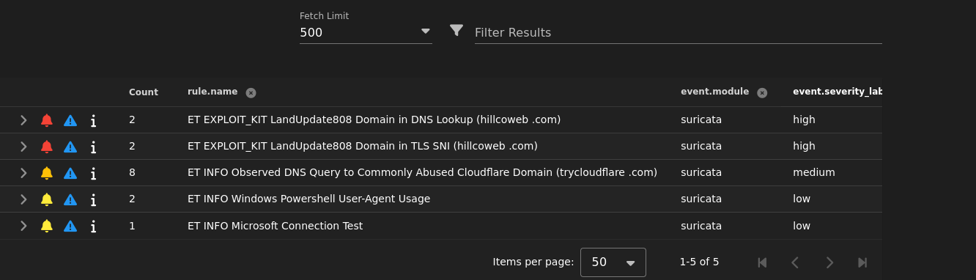
Pivoting and Correlation:
Tracked the source IP (10.6.13.133) responsible for repeated queries.
Correlated timestamps and frequency — queries were sent every few seconds, suggesting automated beaconing.
Used Kibana visualizations to view DNS query volume over time — periodic peaks confirmed the pattern.
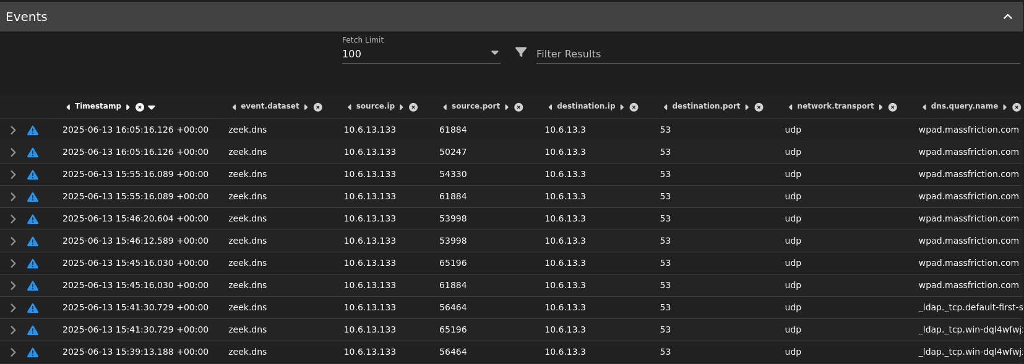

Findings
The source host made dozens of DNS queries to suspicious, non-existent domains within a short time.
This matches behavior of malware using DNS tunneling or DGA-based C2.
Suricata provided supporting evidence with multiple DNS anomaly alerts.
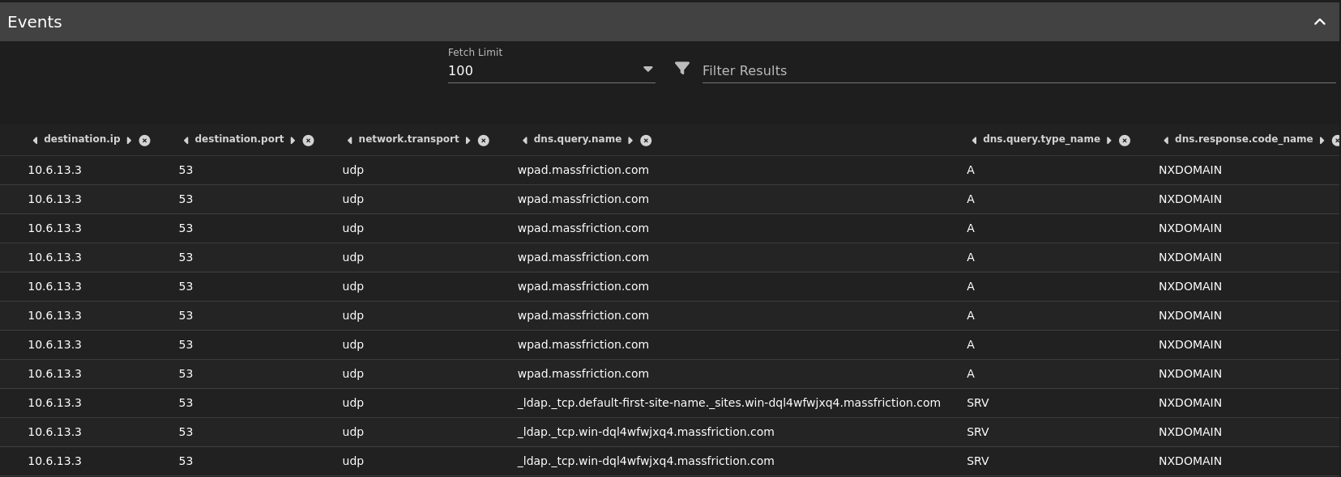

Defensive Actions
Added suspicious domains to a local DNS blocklist.
Configured Zeek intelligence feeds for faster detection of malicious domains.
Implemented alert correlation rules in Security Onion for recurring DNS anomalies.
Recommended endpoint analysis of the source machine for signs of malware infection.

Key Takeaways
DNS traffic can often reveal early-stage malware activity that bypasses other controls.
Zeek’s protocol analysis and Suricata’s signatures complement each other in detecting DNS-based C2.
Regular monitoring and anomaly detection in DNS logs are vital for identifying stealthy threats.
Tools Used
Security Onion, Zeek, Suricata, Kibana, nslookup, Wireshark
Tags
#CyberSecurity #ThreatDetection #DNSAnalysis #BlueTeam #SecurityOnion #Zeek #Suricata #IncidentResponse #CyberDefense #MalwareAnalysis

